BHASHADAAN FEEDBACK ANALYSIS REPORT

1.TOP MODELS USED
A total of six core models were tracked based on service requests. The model ai4bharat/indictrans-v2-all-gpu--t4 processed the vast majority of the volume.
service_id
ai4bharat/indictrans-v2-all-gpu--t4 1496
bhashini/iiith/nmt-all 403
ai4bharat/indictrans-v2-all-gpu--t4/btp 125
Bhashini/IIITH/Trans/V2 120
Bhashini/IIITH/Trans/V1 93
Bhashini/IITM/TTS 58

2. TASK DISTRIBUTION ANALYSIS
The platform supports four core language processing tasks: Translation, Automated Speech Recognition (ASR), Text-to-Speech (TTS), and Text Language Detection. Translation constitutes the overwhelming majority of all platform activity

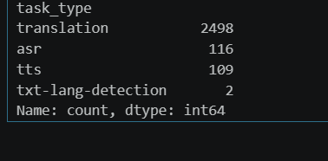

3. LANGUAGE BREAKDOWN BY TASK TYPE
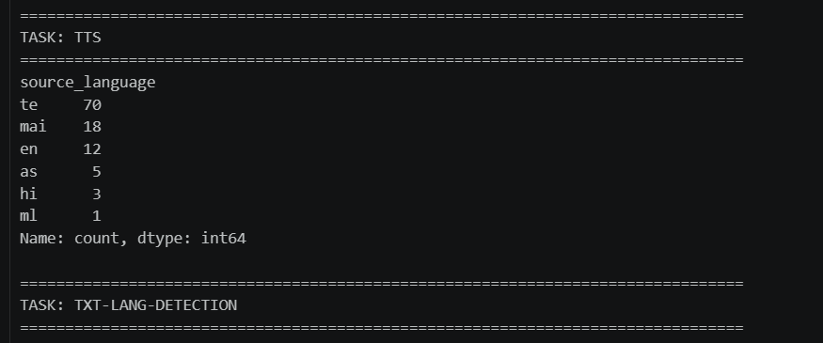
I. Task: Translation
English ($en$) is overwhelmingly the primary source language for translation workloads.
II. Task: ASR (Automatic Speech Recognition)
Speech recognition workloads show a more distributed language mix between English and Kashmiri ($ks$).
- en: 38
- ks: 38
- te: 31
- hi: 5
- bn: 4
III. Task: TTS (Text-to-Speech)
Telugu ($te$) leads the text-to-speech generation requests, followed by Maithili ($mai$).
- te: 70
- mai: 18
- en: 12
- as: 5
- hi: 3
- ml: 1
IV. Task: TXT-LANG-DETECTION
- Note: This task recorded a negligible volume (2 requests total) during this logging period, indicating it is either a secondary feature or rarely invoked by end-users.

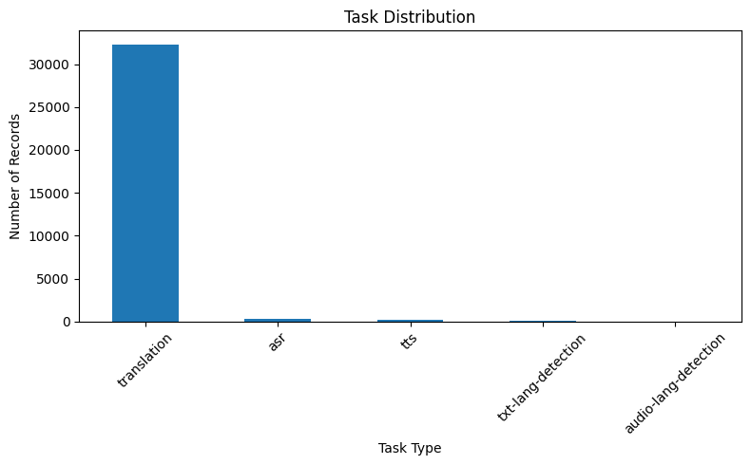

4.Rating Alignment & Pipeline Consistency
A critical metric for evaluating the platform's automated quality assessment is comparing the system's Pipeline Rating against actual User Feedback Ratings.
Key Finding: Out of 1,632 total compared rows, the pipeline rating and feedback ratings matched only 20 times. This extremely low consistency rate ($1.23\%$) suggests a severe mismatch between how the internal system calculates pipeline quality and how human users experience the output.

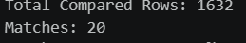
5. Task-Wise Language Distribution
- Translation → Dominated by English (2380), with smaller counts in Malayalam, Hindi, Bengali, etc.
- ASR → Balanced between English (38), Kashmiri (38), Telugu (31).
- TTS → Telugu (70) dominates, followed by Maithili (18), English (12).
- TXT-LANG-DETECTION → No records.

